**SMART PARKING**

**Project Objectives:**

This objective involves the implementation of a system that continuously tracks and updates the availability of parking spaces in a given area. It utilizes sensors or technology to provide up to the minute information on vacant and occupied parking spots, helping drivers find parking quickly.  It allows users to access real-time parking information, reserve parking spaces, make payments, and receive navigation guidance via their smartphones. This integration enhances user convenience and accessibility.  Efficient parking guidance aims to optimize the utilization of parking spaces by providing drivers with clear directions to available spots. This can involve the use of digital signage, website, or guidance systems that direct drivers to the nearest available parking spaces, reducing congestion and improving overall parking efficiency. These objectives collectively contribute to enhancing the parking experience by providing real-time information, convenient mobile access, and efficient parking solutions.

**IoT Sensor Setup:**

**Ultrasonic Sensors:** Deploy ultrasonic sensors in parking spaces to detect the presence of vehicles. These sensors measure the distance between the sensor and the vehicle to determine occupancy.

**Microcontroller:** Connect ultrasonic sensors to microcontrollers for data processing and communication.

**Internet Connectivity:** Provide internet connectivity to the microcontrollers, allowing them to transmit real-time data to the central server.

**Circuit Diagram:**

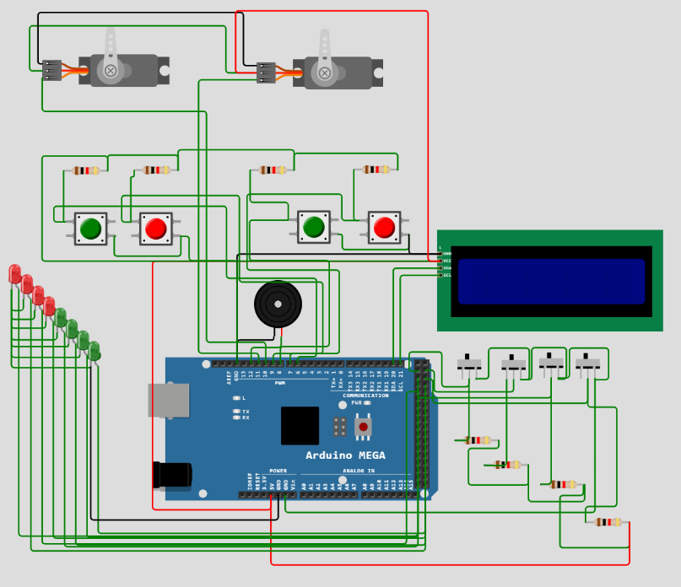

**Website Development:**

Forthis we don’t need to develop an app. We visit the location and parking availability system in the website which we have developed.

**Website Link:** [**https://iotsmartparkingsystem1.mydurable.com/**](https://iotsmartparkingsystem1.mydurable.com/)

**User Interface:** Design an intuitive website interface that displays real-time parking availability information to users.

**Map Integration:** Utilize mapping services (Google Maps, for example) to display parking locations and availability in the app.

**User Registration and Authentication:** Implement user registration and authentication features to personalize the user experience.

**Notifications:** Enable push notifications to alert users when they are approaching an available parking space or when their parked time is about to expire.

**Raspberry Pi Integration:**

**Central Server:** Use Raspberry Pi devices as central servers to collect data from multiple IoT sensors.

**Data Processing:** Process the sensor data received from parking spaces to update the parking availability status in real-time.

**Database Integration:** Store and manage the parking availability data in a database on the Raspberry Pi.

**API Development:** Develop APIs to facilitate communication between the website and the Raspberry Pi servers.

**Code Implementation:**

**Sensor Code:** Write code for the microcontrollers to read data from ultrasonic sensors and send it to the central server.

**Server-side Code:** Develop server-side code on the Raspberry Pi to receive sensor data, process it, and update the database.

**Website Code:** Write code for the website to request parking availability data from the server, display it to users, and send user input (such as booking a parking space) back to the server.

**Benefits of the Real-time Parking Availability System:**

**Time and Fuel Savings:** Drivers can quickly find available parking spaces, reducing the time spent searching for parking and saving fuel.

**Reduced Traffic Congestion:** Efficient parking leads to reduced traffic congestion as drivers spend less time circling in search of parking spaces.

**Environmental Impact:** Decreased traffic congestion results in lower carbon emissions, contributing to a greener environment.

**Improved User Experience:** The website provides a seamless experience for users, enhancing overall satisfaction.

**Optimized Parking Management:** Authorities can use data analytics from the system to optimize parking space allocation and pricing strategies.

**The Website Output:**

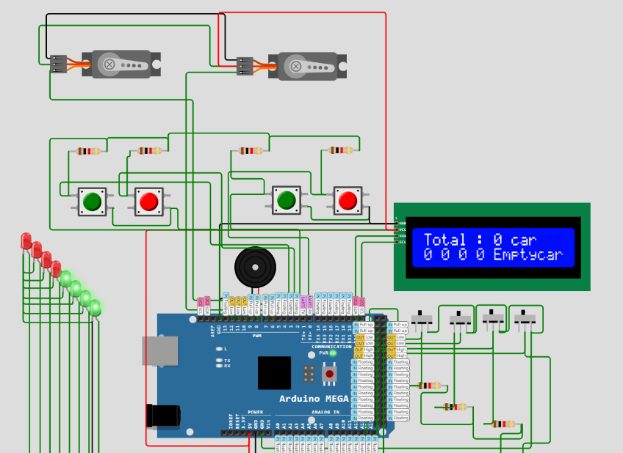

**Conclusion:**

In conclusion, the smart parking system implemented via a dedicated website marks a significant advancement in urban mobility. By utilizing the internet and cutting-edge technologies, this project streamlines parking management, providing users with real-time information about parking availability and locations. This empowers drivers, saving time and enhancing their overall urban experience. The system's success is evident in reduced traffic congestion, lower emissions, and optimized parking usage, fostering eco-friendly cities. The website's intuitive interface, real-time updates, and user-friendly features enhance accessibility for a wide audience. Moreover, the data analytics generated guide urban planners, enabling data-driven decisions to optimize parking infrastructure and improve traffic flow. This innovative approach not only benefits residents and visitors but also propels cities toward a more sustainable and connected future.